**Exercise**

**Q1. -**  List out the types of instance based on the pricing model and write a brief about your understanding about it.

**Ans.** - (1). -T2/T3 instance :- These instances support CPU bursting. Like these instances come with a specific quota for CPU cycles per second or minute if these cycles are not used completely , unused will be converted to CPU burst which can be used in need.

(2). - General Purpose Instances :- They are designed to optimize performance and make balance between computing , traffic and performance.They are used for containerised services like docker and microservices.

(3). - Memory Optimized :- These are designed for workloads that require large datasets for processing.R4 , R3 and R5 belong to that family of instances.

(4). - Accelerated Computing instance :- These instances are ideal for compute-intensive applications and those require parallel processing, such as machine learning, high-resolution graphics processing.

(5). - On Demand instances :- These are generally used for short term processes where flexibility is needed . These work on pay as you go model where we have to pay only for the resources we have used.

**Q2.** - Host a static website in S3

Ans. - steps to host a :-

1. - create a bucket after choosing 3 service from console management dashboard.
2. Select the name , allow public access and save changes.
3. Upload the website files like html,css and js files and save.
4. Go to properties and enable static web hosting , give the home file in the required field.
5. Go to policies and allow public read access and save changes then the website goes live.

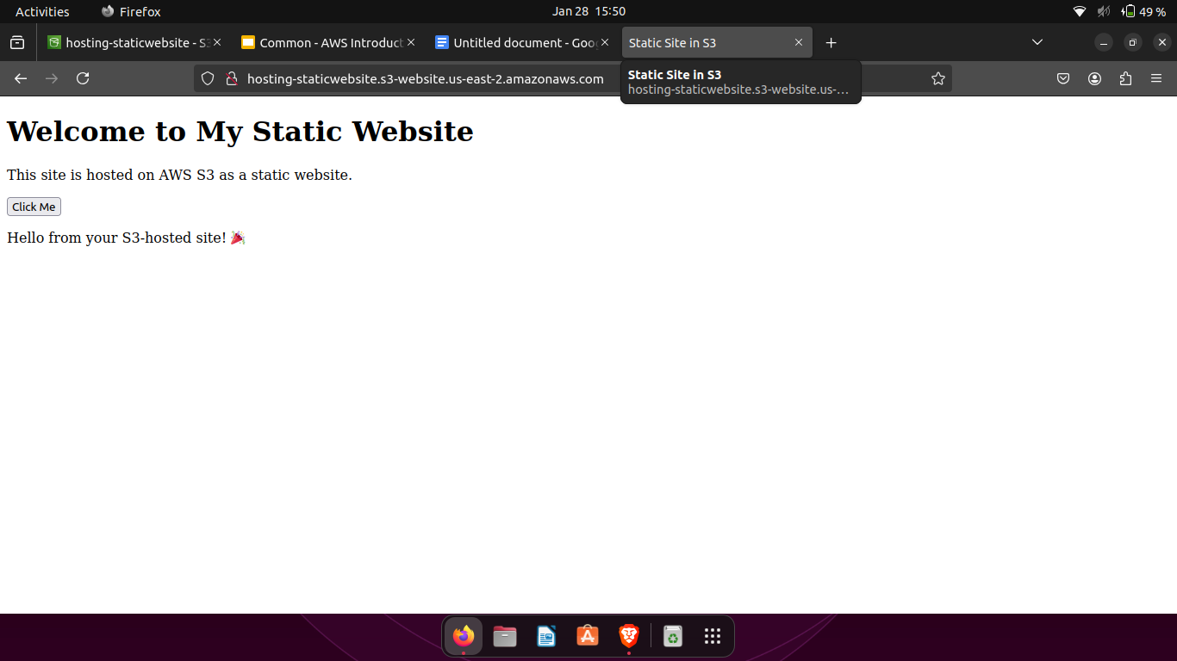

**Q3.** - Launch an Ubuntu EC2 instance on AWS, with 10GB root volume, and SSH from your local machine using the private key.

**Ans.** - search for ec2 service on aws . create and download key pair public key as pem . choose the root volume of the server (10 GB root volume) launch the instance then it shows state as running. Go to the folder where downloaded key is kept.

Run the command shown on the connect with ssh page in ec2 instance dashboard and we connected to the remote ec2 using ssh.

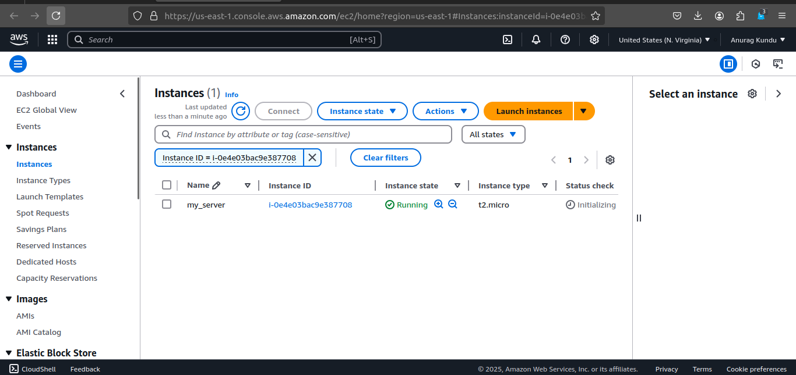

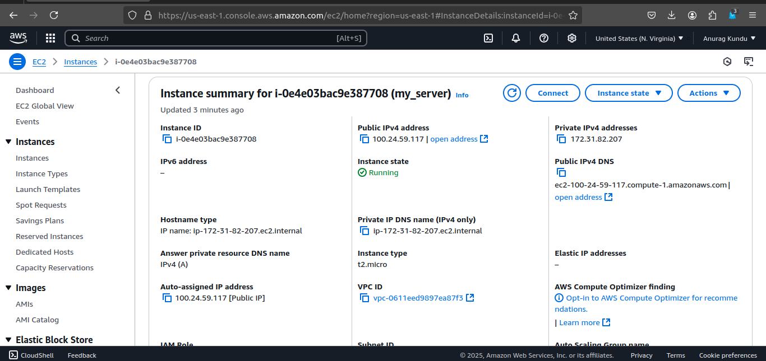

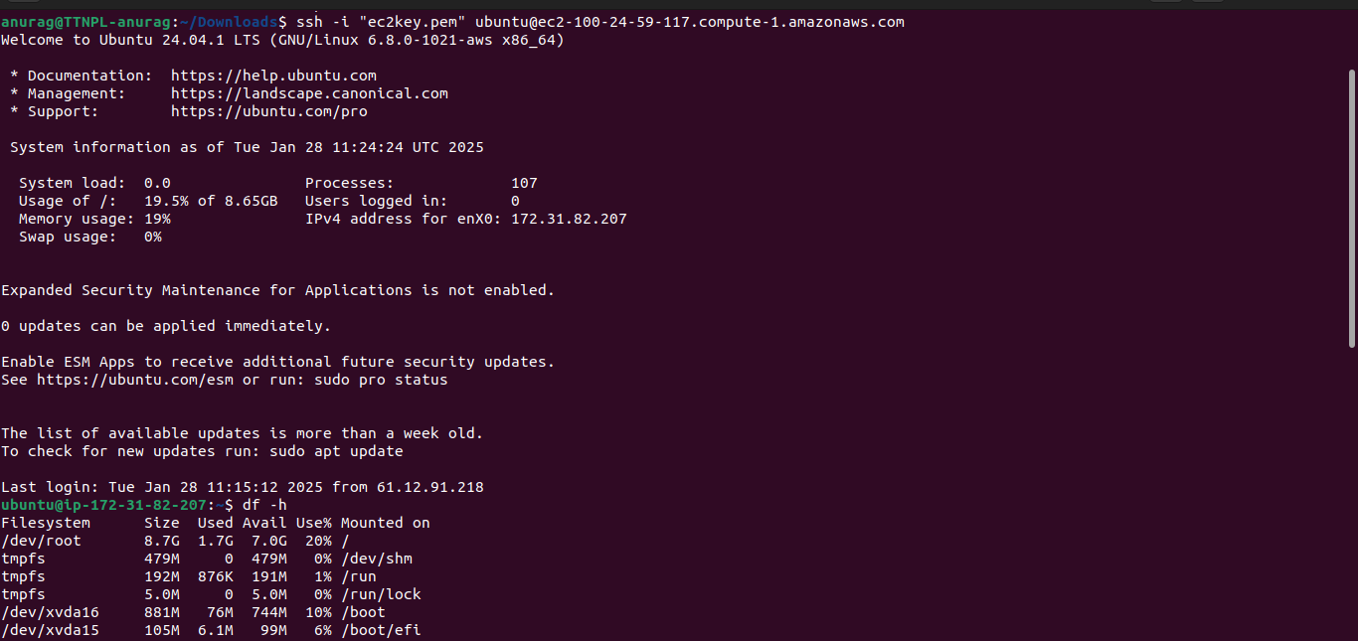

**Q4.** - Install nginx package in the above server and access this page from your local browser using a domain name instead of IP address of the server.

**Ans.** - install the nginx while connected to the ec2 using sudo privilege then start the nginx service using sudo systemctl start nginx and copy the ip address of ec2 server and run on browser there nginx server is running on it.

